Company
Profile

Softstar ITS Pvt. Ltd. defines designs and delivers technology-enabled solutions. We always believe in
advance technology and stability. We have advance system in Toll Highways, Smart city and securities.
We have ready solutions for RFID Reader and handheld reader, Boom Barrier, Emergency call box (ECB),
PBSC Bike sharing system, Facial detection system and ATMS system. We also have professional
Service experiences in Toll (TMS & ETC), ATMS/ HTMS.

Our Major on ECB Projects:-
- We have installed own developed ECB(Emergency call box) at Hosur Krishanagiri highway
(Tamilnadhu) and maintaining it.
- We have installed own developed ECB (Emergency call box) at and at Kandla Mundra Highway (Gujrat), and maintaining it.

Company Objective

To provide the Advance, Secure
& Best service to make
Trustable relationship with client.

Company Products

ECB Solution

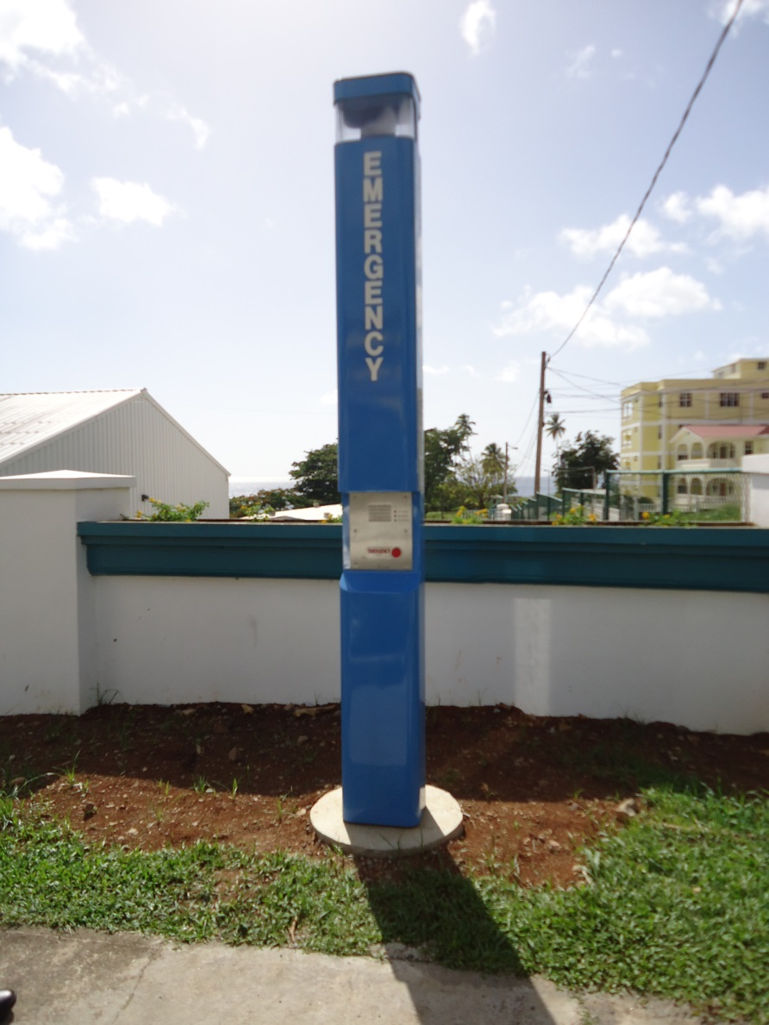
Softstar ITS have developed own ECB (emergency call box) system on both fiber and GSM network.

It is more stable with less power consumption. It designed according to hard Indian weather.

ECB

GSM ECB (Model SSGE103) Technical details:
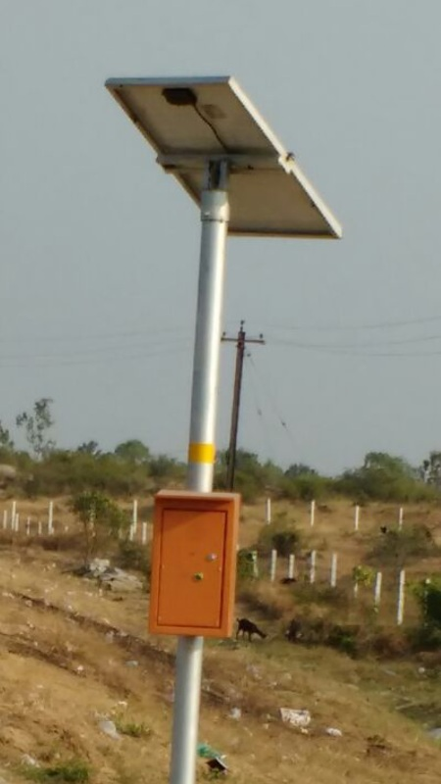

Function Module | Technical Specifications
Mother board | With GS1000 chip power
Formats | GSM 900 MHZ / 1800 MHZ
Power-supply modes | Solar power supply and Battery DC12V 17Ah
DC Supply | Max 12V, Minimum 5V DC
Standby Current | 30 Milliamps
Working Current | 1 to 1.5 Amp
Environment Temperature | -5 to 50 Degree C
Relative humidity | 10% - 90%
Mice Sensitivity | Max talking distance 15 cm
Door closer | Door closer sensor
Antenna | AMPS/GSM/PCS/UMTS: 824 to 960/1710 to 2170MHz
 | Gain: 7dBi
 | UMTS: 2100 to 2170MHz
 | AMPS: 850MHz
 | PCS: 1900MHz
Audio Amplifier output | 10 Watt Max
Control Room setup | Voice Data Recorder 4 Channel
 | Control Room Software with headphone
 | GSM logger with Antenna

